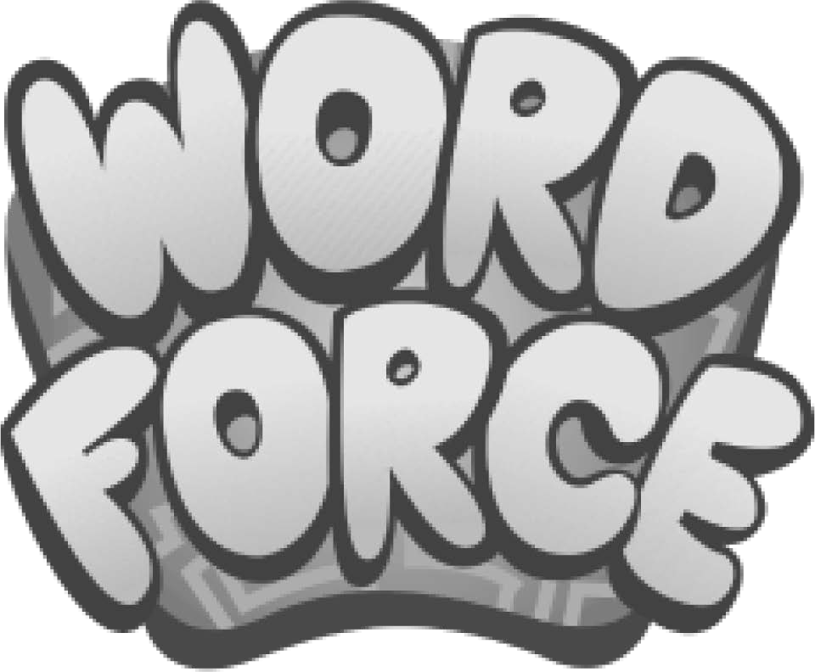

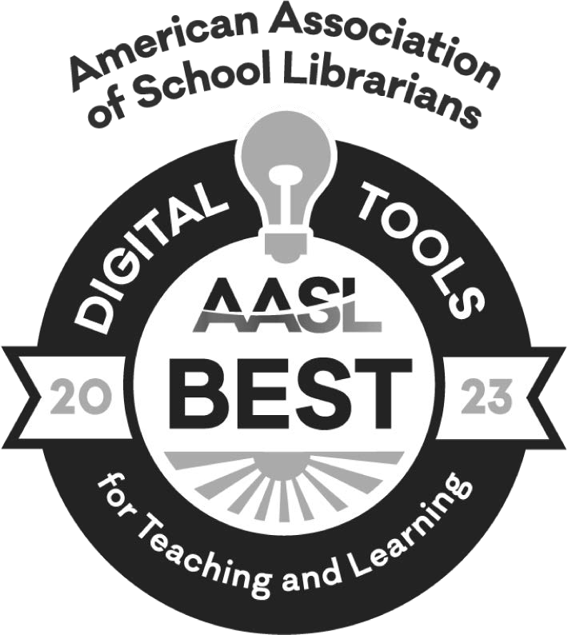
LIBRARY NAME
ADDRESS
CITY, STATE, ZIP DATE

Dear Parent and/or Guardian,

I am excited to share WORD Force Reading Adventures with you! Powered by EVERFI, WORD Force Reading Adventures is a free game-based mobile application that teaches children foundational literacy skills. In May, WORD Force was named a 2023 Best Digital Tool for Teaching & Learning by the American Association of School Librarians.

In WORD Force Reading Adventures, your child will assume the role of commander, leading a group of dynamic superheroes through 15 interactive games that build skills for beginning reading, including:

- Phonological awareness (rhyme awareness, onset-rime awareness, phonemic awareness)
- Letter-sound/letter name matching
- Word building/Spelling
- Vocabulary, including high-frequency words
- Reading comprehension

(LIBRARY NAME) hopes that this resource is helpful as your family continues their summer reading journey.

To learn more about WORD Force Reading Adventures head to https:// wordforce.everfi.com/, scan the QR code below, or simply search "WORD Force" in the Apple App Store or Google Play Store on your family's mobile devices.

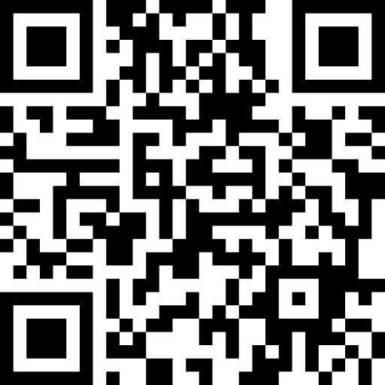
Best Regards,

LIBRARY POINT-OF-CONTACT, LIBRARY NAME

